- Discontinue Previous Insulin Orders
- Fingerstick Glucose four times daily: before meals and nightly
- Diet: Add Carbohydrate Consistent Diet with 6 carbohydrates units per meal.
- When patient not eating use ADJUSTED Humalog DOSE, which equals DOSE DUE minus BASE DOSE
- Long acting insulin to be given subcutaneous:
Lantus insulin 22 units subcutaneous Nightly
- Humalog Insulin units subcutaneous as directed in the below algorithm.
Blood Glucose (mg/dL) | Breakfast  (Units Humalog Insulin) | Lunch  (Units Humalog Insulin) | Supper  (Units Humalog Insulin) | Nighttime  (Units Humalog Insulin)
<70 | Treat the hypoglycemic episode per hypoglycemia protocol
70-90 | 5 | 4 | 4 | 0
91-130  (Base Dose) | 9 | 8 | 7 | 0
131-150 | 10 | 9 | 8 | 0
151-200 | 11 | 10 | 9 | 0
201-250 | 12 | 11 | 10 | 0
251-300 | 13 | 12 | 11 | 1
301-350 | 14 | 13 | 12 | 2
351-400 | 15 | 14 | 13 | 3
401-450 | 16 | 15 | 14 | 4
>450 | 17 | 16 | 15 | 5
Provider Signature: _____________________________ID No:_____________________
Date: July 31, 2026___________________Time: 09:43______________________
RN Signature: __________________________________ Date/Time: _____________

Froedtert Hospital
9200 West Wisconsin Avenue
PO Box 26099
Milwaukee, WI 53226

Primary Affiliate of the
Medical College of Wisconsin

Version 5/30/06, Owner: Endocrine
Copy 1 – Chart
Copy 2 – Nursing
Copy 3 -- Pharmacy

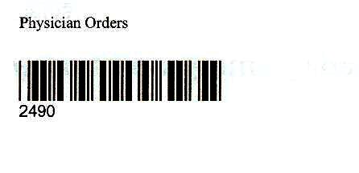

Physician Order Sheet

