Blood Glucose (mg/dL) | Breakfast  (Units Humalog Insulin) | Lunch  (Units Humalog Insulin) | Supper  (Units Humalog Insulin) | Nighttime  (Units Humalog Insulin)
<70 | Treat the low blood sugar. Recheck blood glucose in 15 mins. If sugar is more than 70, then take the number of units of insulin in the 70-90 row, if before a meal.
70-90 | 1 | 1 | 2 | 0
91-130  (Base Dose) | 2 | 3 | 4 | 0
131-150 | 3 | 4 | 5 | 0
151-200 | 4 | 5 | 6 | 0
201-250 | 5 | 6 | 7 | 0
251-300 | 6 | 7 | 8 | 1
301-350 | 7 | 8 | 9 | 2
351-400 | 8 | 9 | 10 | 3
401-450 | 9 | 10 | 11 | 4
>450 | 10 | 11 | 12 | 5
Lantus insulin 22 units subcutaneous Nightly

Provider Signature: _____________________________ID No:_____________________
Date: July 28, 2026___________________Time: 15:26______________________
RN Signature: __________________________________ Date/Time: _____________

Froedtert Hospital
9200 West Wisconsin Avenue
PO Box 26099
Milwaukee, WI 53226

Primary Affiliate of the
Medical College of Wisconsin

Version 1/7/08, Owner: Endocrine
Copy 1-3 - Patient
Copy 4 – Chart
Copy 5 – Nursing
Copy 6 -- Pharmacy

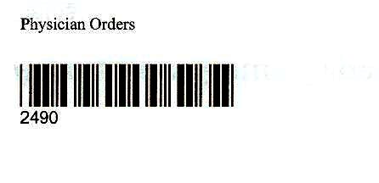

Physician Order Sheet

