Blood Glucose (mg/dL) | Breakfast  (Units Insulin 70/30) | Supper  (Units Insulin 70/30)
<70 | Treat the low blood sugar. Recheck blood glucose in 15 mins. If sugar is more than 70, then take the number of units of insulin in the 70-90 row, if before breakfast or supper.
70-90 | 26 | 13
91-130
(Base Dose)
131-150 | 46 | 24
151-200 | 48 | 26
201-250 | 50 | 28
251-300 | 52 | 30
301-350 | 54 | 32
351-400 | 56 | 34
401-450 | 58 | 36
>450 | 60 | 38
Provider Signature: _____________________________ID No:_____________________
Date: July 31, 2026___________________Time: 12:02______________________
RN Signature: __________________________________ Date/Time: _____________

Froedtert Hospital
9200 West Wisconsin Avenue
PO Box 26099
Milwaukee, WI 53226

Primary Affiliate of the
Medical College of Wisconsin

Version 1/28/08, Owner: Endocrine
Copy 1-3 -- Patient
Copy 4 – Chart
Copy 5 – Nursing
Copy 6 -- Pharmacy

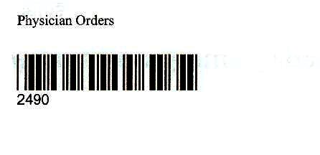

Physician Order Sheet

