- Discontinue Previous Insulin Orders
- Fingerstick Glucose four times daily: before meals and nightly
- Diet: Add Carbohydrate Consistent Diet with 5 carbohydrates units per meal.

- Insulin 70/30 units subcutaneous as directed in the below algorithm.
Blood Glucose (mg/dL) | Breakfast  (Units Insulin 70/30) | Supper  (Units Insulin 70/30)
<70 | Treat the hypoglycemic episode per hypoglycemia protocol
70-90 | 19 | 13
91-130
(Base Dose)
131-150 | 35 | 24
151-200 | 37 | 26
201-250 | 39 | 28
251-300 | 41 | 30
301-350 | 43 | 32
351-400 | 45 | 34
401-450 | 47 | 36
>450 | 49 | 38
Provider Signature: _____________________________ID No:_____________________
Date: July 28, 2026___________________Time: 17:05______________________
RN Signature: __________________________________ Date/Time: _____________

Froedtert Hospital
9200 West Wisconsin Avenue
PO Box 26099
Milwaukee, WI 53226

Primary Affiliate of the
Medical College of Wisconsin

Version 5/30/06, Owner: Endocrine
Copy 1 – Chart
Copy 2 – Nursing
Copy 3 -- Pharmacy

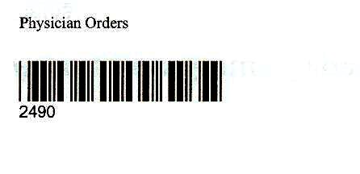

Physician Order Sheet

