- Discontinue Previous Insulin Orders
- Fingerstick Glucose EIGHT times daily: before meals, 2 hours post-prandially , nightly, and 0300
- Glucose Goal: 60-100 before meals and 0300; less than 130 2 hours after meals
- Long acting insulin to be given subcutaneous:
NPH insulin 11 units subcutaneous at breakfast
NPH insulin 11 units subcutaneous nightly
- Humalog Insulin units subcutaneous as directed in the below algorithm.
Blood Glucose (mg/dL) | Breakfast  (Units Humalog) | Lunch  (Units Humalog) | Supper  (Units Humalog) | 2Hour-Postprandial, Nighttime, and 0300  (Units Humalog)
<50 | Treat the hypoglycemic episode per hypoglycemia protocol
50-60 | 5 | 4 | 4 | 0
61-100  (Base Dose) | 9 | 8 | 7 | 0
101-150 | 10 | 9 | 8 | 0
151-200 | 11 | 10 | 9 | 1
201-250 | 12 | 11 | 10 | 2
251-300 | 13 | 12 | 11 | 3
301-350 | 14 | 13 | 12 | 4
351-400 | 15 | 14 | 13 | 5
401-450 | 16 | 15 | 14 | 6
>450 | 17 | 16 | 15 | 7
Provider Signature: _____________________________ID No:_____________________
Date: July 28, 2026___________________Time: 14:07______________________
RN Signature: __________________________________ Date/Time: _____________

Froedtert Hospital
9200 West Wisconsin Avenue
PO Box 26099
Milwaukee, WI 53226

Primary Affiliate of the
Medical College of Wisconsin

Version 9/15/2009, Owner: Endocrine
Copy 1 – Chart
Copy 2 – Nursing
Copy 3 -- Pharmacy

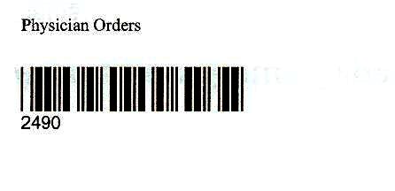

Physician Order Sheet

