- Discontinue Previous Insulin Orders
- Fingerstick Glucose four times daily: every 6 hours
- If tube feedings interrupted use ADJUSTED DOSE, which equals DOSE DUE minus BASE DOSE
- If Regular insulin has been given AND the tube feedings are INTERRUPTED, call primary team for continuous glucose infusion to prevent HYPOGLYCEMIA.
- Long acting insulin to be given subcutaneous:
Lantus insulin 11 units subcutaneous Nightly
- Regular Insulin units subcutaneous as directed in the below algorithm.
Blood Glucose (mg/dL) | 0600  (Units Regular Insulin) With Tube Feeding | 1200  (Units Regular Insulin) With Tube Feeding | 1800  (Units Regular Insulin) With Tube Feeding | 2400  (Units Regular Insulin) With Tube Feeding
<70 | Treat the hypoglycemic episode per hypoglycemia protocol
70-90 | 0 | 1 | 1 | 2
91-130  (Base Dose) | 1 | 2 | 3 | 4
131-150 | 2 | 3 | 4 | 5
151-200 | 3 | 4 | 5 | 6
201-250 | 4 | 5 | 6 | 7
251-300 | 5 | 6 | 7 | 8
301-350 | 6 | 7 | 8 | 9
351-400 | 7 | 8 | 9 | 10
401-450 | 8 | 9 | 10 | 11
>450 | 9 | 10 | 11 | 12
Provider Signature: _____________________________ID No:_____________________
Date: July 31, 2026___________________Time: 09:49______________________
RN Signature: __________________________________ Date/Time: _____________
Froedtert Hospital
9200 West Wisconsin Avenue
PO Box 26099
Milwaukee, WI 53226

Primary Affiliate of the
Medical College of Wisconsin

Version 1/16/12, Owner: Endocrine
Copy 1 – Chart
Copy 2 – Nursing
Copy 3 -- Pharmacy

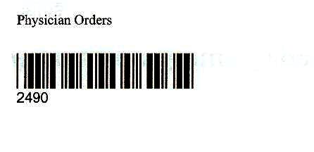

Physician Order Sheet

